Did you know? It takes 75-100 steps and communications to coordinate a surgery
Surgical coordination is a crucial aspect of any successful operation. It involves the coordination of various departments, healthcare professionals, and resources to ensure that a surgery runs smoothly. However, many people are unaware of the complexity and number of steps involved in this process. In this article, we will explore the 75-100 steps and communications required to coordinate a surgery.

Pre-Operative Phase
The pre-operative phase is the first step in surgical coordination. It involves the initial consultation with the patient, where the surgeon assesses the patient's medical history and determines the need for surgery. This phase also includes obtaining consent from the patient, scheduling the surgery, and conducting pre-operative tests and evaluations.

Consultation and Assessment
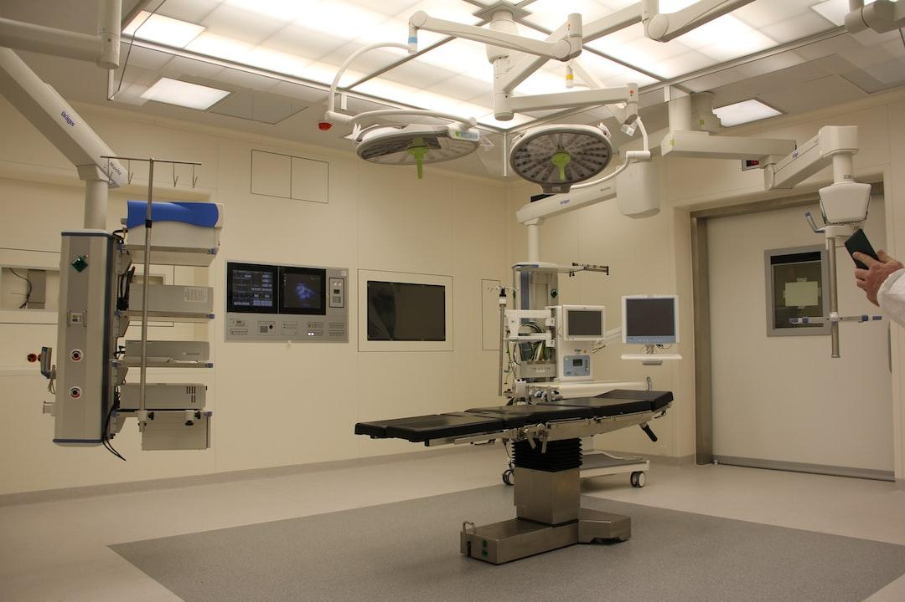
by Marcel Scholte (https://unsplash.com/@mscholte)
The consultation and assessment phase is crucial as it sets the foundation for the entire surgical process. The surgeon must gather all necessary information about the patient's medical history, current condition, and any potential risks or complications. This information is used to determine the best course of action for the surgery.

Consent and Scheduling
Once the surgeon has determined the need for surgery, they must obtain consent from the patient. This involves explaining the procedure, potential risks, and expected outcomes to the patient. Once consent is obtained, the surgery is scheduled, taking into consideration the availability of the surgeon, operating room, and necessary equipment.

Pre-Operative Tests and Evaluations
Before a surgery can take place, the patient must undergo various tests and evaluations to ensure they are physically prepared for the procedure. These may include blood tests, X-rays, and EKGs. The results of these tests are reviewed by the surgeon and anesthesiologist to determine if any additional precautions or preparations are needed.

Intra-Operative Phase
The intra-operative phase is the actual surgery itself. This phase involves coordinating various departments and healthcare professionals to ensure the surgery runs smoothly.

Operating Room Preparation
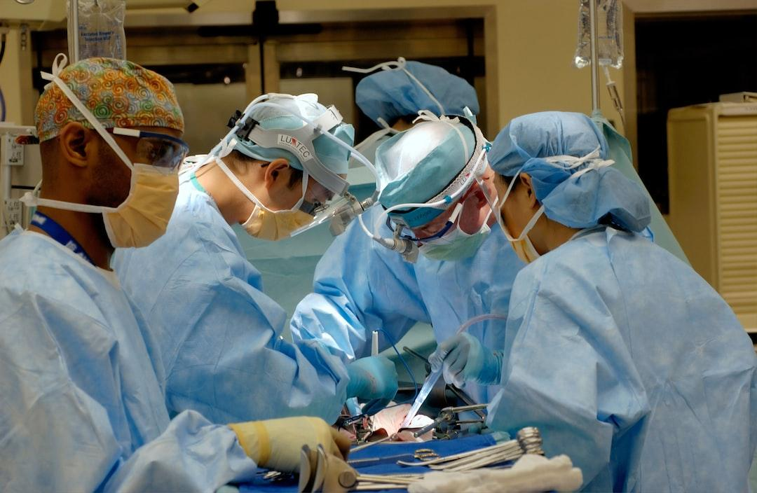
by National Cancer Institute (https://unsplash.com/@nci)
The operating room must be prepared before the surgery can begin. This includes sterilizing the room, setting up necessary equipment, and ensuring all necessary supplies are available.

Anesthesia Administration
The anesthesiologist is responsible for administering anesthesia to the patient. This involves monitoring the patient's vital signs and adjusting the anesthesia as needed throughout the surgery.

Surgical Team Coordination
The surgical team, including the surgeon, nurses, and technicians, must work together seamlessly during the surgery. This involves clear communication and coordination to ensure the procedure is performed accurately and efficiently.

Post-Operative Phase
The post-operative phase is the final step in surgical coordination. It involves monitoring the patient's recovery and providing necessary care and instructions.

Recovery and Discharge

by Markus Spiske (https://unsplash.com/@markusspiske)
After the surgery is complete, the patient is moved to a recovery room where they are monitored until they are stable enough to be discharged. The surgeon will provide post-operative instructions and any necessary medications before the patient is discharged.

Follow-Up Care
The surgical coordination process does not end with the surgery. Follow-up care is essential to ensure the patient's full recovery. This may include post-operative appointments, physical therapy, or home care.
By understanding the complexity and number of steps involved in surgical coordination, we can appreciate the hard work and dedication of healthcare professionals in ensuring successful surgeries. Next time you or a loved one undergoes surgery, remember the 75-100 steps and communications that went into coordinating the procedure.

